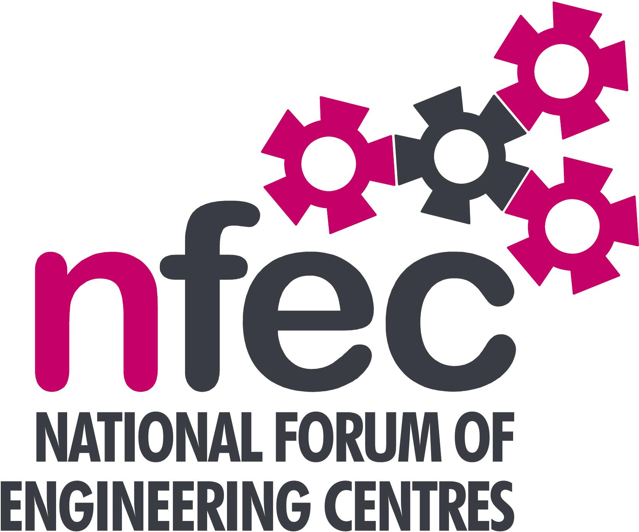
NFEC Autumn 2016
South West Regional Seminar

Friday 18th November 2016, 10.15am - 15.00 (Coffee from 10am)
Venue: Petroc, Mid Devon Campus, Bolham Road, Tiverton EX16 6SH
Telephone Number: 01884 235200

Programme

- Welcome and Introduction to the Seminar | Chris Miller (South West Regional Coordinator and City of Plymouth College) | 10.15
- Current matters of concern relating to quality, content, structure, management and delivery of programmes of training and education in Engineering (not included on Agenda) - an opportunity for open discussion with a focus to distill key issues and plans for addressing them. | All Delegates/Chris Miller | 10.25
- Remote and e-portfolio assessment app  - The Composites Technician Trailblazer Apprenticeship - An opportunity  - Qualifications and Awarding Bodies – Current developments and general issues  Lunch & Demonstrations by Exhibitors  - Apprenticeship Traiblazer Initiative - Update on Trailblazer Developments and related issues. This is a discussion item, based on documents supplied by Bob Millington.  - Tour of Facilities  - Date, Place and Topics for next Seminar  - Seminar Closes. | Jason Ferrett, One File  Brian Thornton, National Composites Centre  Dean Jones, Trailblazer Chair, Rolls Royce  Bill Lockyer - EAL  Bridget Stait -Edexcel  Chris Miller  Petroc | 10.45  11.30  12.15  12.45  13.30  14.15
Entry is free to this seminar for members or non-members present for a first attendance.There will be a charge for non members after this. A light buffet lunch will be provided and you will be able to see/discuss demonstrations of the latest available equipment and facilities for the delivery of learning in Engineering | To book your place:  Email: admin@nfec.org.uk  Phone: 07759 901229

